Google Cloud Build Container Scan
Integrate AccuKnox container image scanning into Google Cloud Build to catch vulnerabilities in your Docker images before they ship to production. The pipeline builds your image, scans it with ASPM Scanner CLI, optionally generates a CycloneDX SBOM, and uploads findings directly to your AccuKnox CSPM panel.

Prerequisites
• GCP project with Cloud Build enabled
• AccuKnox SaaS access with permission to generate tokens
• A repository with a Dockerfile at the root (or a path you specify)
• A Cloud Build trigger pointing at the repository

Steps for integration

Step 1: Generate an AccuKnox token
Log in to AccuKnox SaaS. Navigate to Settings, then Tokens and create a new token.
[Screenshot:
AccuKnox token generation page]Save these three values for use in Step 3:
Field | Where to find it
Endpoint | Your AccuKnox CSPM URL, for example, cspm.demo.accuknox.com
Token | The token string shown after creation
Label | Any descriptive string you choose

Step 2: Add the cloudbuild.yaml to your repository
Drop the following file at the root of your repository as cloudbuild.yaml. The AccuKnox credentials come from the Cloud Build trigger config (Step 3). The image-specific values (name, tag, Dockerfile path, severity, SBOM options) are edited directly in step 3 of the YAML.
# =============================================================================
# AccuKnox Container Scan (Trivy) — Google Cloud Build Pipeline
# Builds the image, runs a Trivy vulnerability scan, optionally generates an SBOM.
# =============================================================================

steps:

# ---------------------------------------------------------------------------
# Step 1: Validate required AccuKnox inputs (fail fast)
# ---------------------------------------------------------------------------
- id: validate-inputs
name: ubuntu:24.04
entrypoint: bash
env:
- ACCUKNOX_ENDPOINT=${_ACCUKNOX_ENDPOINT}
- ACCUKNOX_TOKEN=${_ACCUKNOX_TOKEN}
- ACCUKNOX_LABEL=${_ACCUKNOX_LABEL}
args:
- -c
- |
set -e
echo "Validating required inputs..."
if [ -z "$$ACCUKNOX_ENDPOINT" ] || [ -z "$$ACCUKNOX_TOKEN" ] || [ -z "$$ACCUKNOX_LABEL" ]; then
echo "ERROR: _ACCUKNOX_ENDPOINT, _ACCUKNOX_TOKEN, and _ACCUKNOX_LABEL must be set!"
exit 1
fi
echo "All required inputs present."

# ---------------------------------------------------------------------------
# Step 2: Download the AccuKnox ASPM Scanner CLI
# ---------------------------------------------------------------------------
- id: download-scanner
name: ubuntu:24.04
entrypoint: bash
args:
- -c
- |
set -e
export DEBIAN_FRONTEND=noninteractive
apt-get update -qq
apt-get install -y -qq --no-install-recommends curl ca-certificates

echo "Downloading AccuKnox ASPM Scanner v0.14.2..."
curl -sSL https://github.com/accuknox/aspm-scanner-cli/releases/download/v0.14.2/accuknox-aspm-scanner \
-o /workspace/accuknox-aspm-scanner
chmod +x /workspace/accuknox-aspm-scanner

# ---------------------------------------------------------------------------
# Step 3: Build the image, run vulnerability scan, optionally run SBOM scan
# ---------------------------------------------------------------------------
- id: run-container-scan
name: ubuntu:24.04
entrypoint: bash
env:
- ACCUKNOX_ENDPOINT=${_ACCUKNOX_ENDPOINT}
- ACCUKNOX_TOKEN=${_ACCUKNOX_TOKEN}
- ACCUKNOX_LABEL=${_ACCUKNOX_LABEL}
args:
- -c
- |
set -e

# ====================================================================
# Container scan configuration — edit these values as needed
# ====================================================================
IMAGE_NAME="my-app"
TAG="latest"
DOCKERFILE_CONTEXT="Dockerfile"
SEVERITY="UNKNOWN,LOW,MEDIUM,HIGH,CRITICAL"
SOFT_FAIL="true"
GENERATE_SBOM="false"
PROJECT_NAME=""
# ====================================================================

export DEBIAN_FRONTEND=noninteractive
apt-get update -qq
apt-get install -y -qq --no-install-recommends ca-certificates docker.io
export DOCKER_API_VERSION=1.41
cd /workspace

GENERATE_SBOM="$${GENERATE_SBOM,,}"
GENERATE_SBOM=$(echo "$$GENERATE_SBOM" | tr -d ' \t\r\n')
if [ "$$GENERATE_SBOM" = "true" ] && [ -z "$$PROJECT_NAME" ]; then
echo "ERROR: PROJECT_NAME is required when GENERATE_SBOM is true!"
exit 1
fi

echo "Building Docker image $$IMAGE_NAME:$$TAG ..."
docker build -t "$$IMAGE_NAME:$$TAG" -f "$$DOCKERFILE_CONTEXT" .

echo "Saving image to /workspace/image.tar ..."
docker save "$$IMAGE_NAME:$$TAG" -o /workspace/image.tar

touch /workspace/results.json
chmod 666 /workspace/results.json

echo "Installing container scan tool..."
/workspace/accuknox-aspm-scanner tool install --type container

SOFT_FAIL="$${SOFT_FAIL,,}"
SOFT_FAIL=$(echo "$$SOFT_FAIL" | tr -d ' \t\r\n')
SOFT_FAIL_ARG=""
if [ "$$SOFT_FAIL" = "true" ]; then
SOFT_FAIL_ARG="--softfail"
fi

CMD="image --input /workspace/image.tar"
if [ -n "$$SEVERITY" ]; then
CMD="$$CMD --severity $$SEVERITY"
fi

echo "Running AccuKnox vulnerability scan..."
/workspace/accuknox-aspm-scanner scan \
$$SOFT_FAIL_ARG \
--keep-results \
container \
--command "$$CMD"

cp /workspace/results.json /workspace/results-vuln.json

if [ "$$GENERATE_SBOM" = "true" ]; then
echo "Running AccuKnox SBOM scan..."
/workspace/accuknox-aspm-scanner scan \
$$SOFT_FAIL_ARG \
--keep-results \
--project-name "$$PROJECT_NAME" \
container \
--command "$$CMD" \
--generate-sbom

cp /workspace/results.json /workspace/results-sbom.json
fi

# =============================================================================
# Substitutions (only AccuKnox credentials — set these in the trigger UI)
# _ACCUKNOX_ENDPOINT -> accuknox_endpoint (required)
# _ACCUKNOX_TOKEN -> accuknox_token (required)
# _ACCUKNOX_LABEL -> accuknox_label (required, e.g. "container-myapp")
# =============================================================================
substitutions:
_ACCUKNOX_ENDPOINT: ""
_ACCUKNOX_TOKEN: ""
_ACCUKNOX_LABEL: ""

options:
logging: CLOUD_LOGGING_ONLY
machineType: E2_HIGHCPU_8

timeout: 1800s

Before committing, edit the configuration block in step 3 to match your image:
Variable | What to set
IMAGE_NAME | The image name without a tag, for example, my-app
TAG | The image tag, for example, latest or v1.2.3
DOCKERFILE_CONTEXT | Path to your Dockerfile, default is Dockerfile
SEVERITY | Comma-separated severities to report. Default reports all: UNKNOWN, LOW, MEDIUM, HIGH, CRITICAL
SOFT_FAIL | true to keep the pipeline green on findings, false to fail the build
GENERATE_SBOM | true to also run a second scan that produces a CycloneDX SBOM, false to skip
PROJECT_NAME | Required only when GENERATE_SBOM=true. Used as the SBOM entity in AccuKnox CSPM.

Commit and push the file to your repository.

Step 3: Configure the Cloud Build trigger
Open Cloud Build in the GCP console. Create or edit a trigger pointing at your repository.
Under Configuration, select Cloud Build configuration file and point it at cloudbuild.yaml.
Under Advanced, then Substitution variables, add the three AccuKnox credentials:
Variable name | Value
_ACCUKNOX_ENDPOINT | Your CSPM endpoint, for example, cspm.demo.accuknox.com
_ACCUKNOX_TOKEN | The token from Step 1
_ACCUKNOX_LABEL | A label of your choice, for example, container-myapp

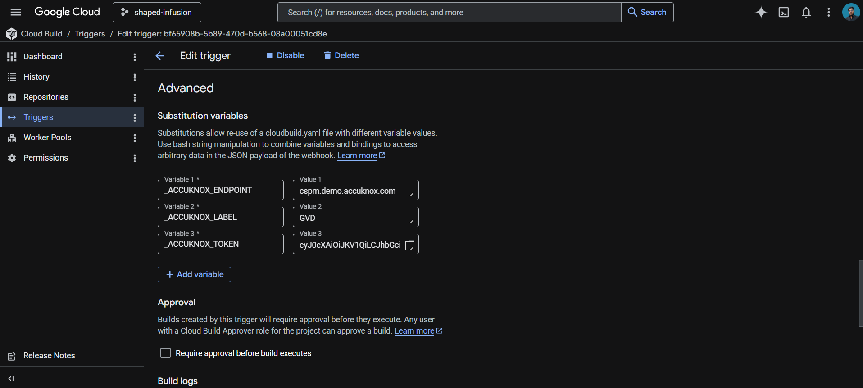
These values live in the trigger config rather than the YAML, which keeps your token out of git history.
Save the trigger. The next push to the watched branch runs the pipeline.

How the pipeline works
Step | Purpose
1. validate-inputs | Fails the build in under a second if any AccuKnox credential is missing. Saves a wasted scanner download.
2. download-scanner | Fetches the AccuKnox ASPM Scanner v0.14.2 binary into /workspace, which persists across Cloud Build steps.
3. run-container-scan | Builds the Docker image, exports it as a tarball, installs Trivy locally, scans the tarball, and uploads findings to AccuKnox CSPM. If GENERATE_SBOM=true, a second scan produces a CycloneDX SBOM.

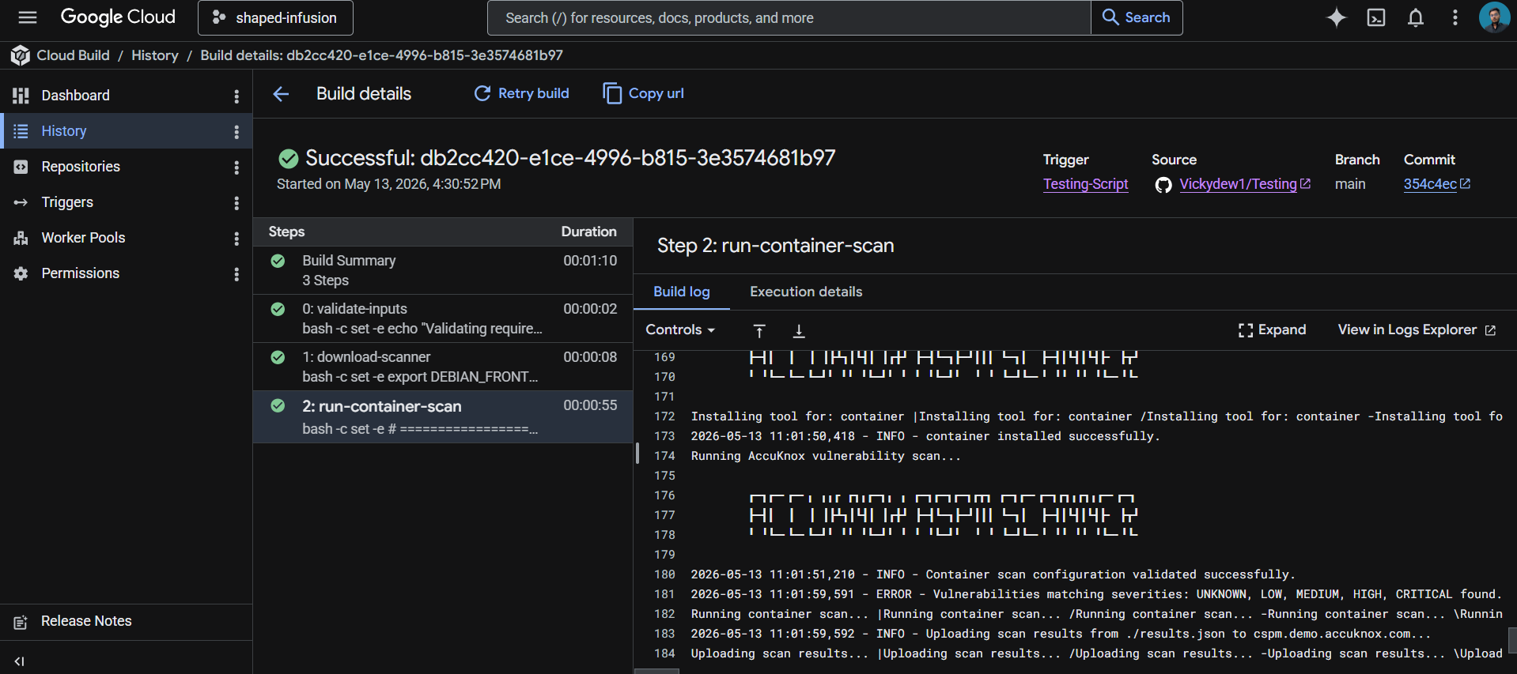

Vulnerability scan vs SBOM
The pipeline can produce two different output files. They serve different purposes:
Output | What it contains and when to use it
results-vuln.json | List of CVEs found in the image, with severity, affected package, and fixed version. Produced on every run. Use for vulnerability management and remediation prioritization.
results-sbom.json | CycloneDX SBOM listing every component in the image. Only produced when GENERATE_SBOM=true. Use for supply chain compliance (SLSA, EO 14028, NIST SSDF) and dependency auditing.

SBOM generation runs as a separate scan because the AccuKnox CLI does not produce both outputs in a single pass. The second run adds about 30 seconds. For regulated environments where SBOMs are required, enable it. For pure vulnerability detection, leave it off.

Viewing results
Open the AccuKnox CSPM panel. Filter findings by the label you set in _ACCUKNOX_LABEL. Each vulnerability finding includes the CVE ID, affected package and version, severity, fixed version (when available), and a link to the upstream advisory. SBOM data shows up under the project name set in PROJECT_NAME.

Before the AccuKnox scan
Without container scanning in your pipeline, vulnerable base images, unpatched OS packages, and dependencies with known CVEs ship to production unchecked. A 6-month-old Node.js base image typically contains dozens of high-severity CVEs. Most teams discover this only after a security audit, or worse, after exploitation.

After AccuKnox scan integration
Once the pipeline above is wired up, every push triggers a build, scan, and upload. Vulnerabilities in OS packages, language dependencies, and the base image surface in your AccuKnox CSPM panel within minutes. Findings include severity, fix availability, and remediation guidance. Critical issues can fail the build by setting SOFT_FAIL to false in step 3 of the YAML.



